**Lab Exercise – 1**

Q1: Write a Python program which accept the radius of a circle from the user and compute the area.

Sample Output :   
r = 1.1  
Area = 3.8013271108436504

Q2: Temperature of a city in Fahrenheit degrees is input through the keyboard. Write a program to convert this temperature into Centigrade degrees.

Q3: Write a Python Program to make a simple calculator that can add, subtract, multiply and divide

Q4: Write a Python Program to calculate the square root

Q5: Write a Python Program to find the area of triangle

# Three sides of the triangle a, b and c are provided by the user

Q6: If a five-digit number is input through the keyboard, write a program to calculate the sum of its digits without using any loop. (Hint: Use the modulus operator ‘%’)

Q7: Write a Python program to print the following string in a specific format

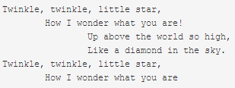

Q8: Write a Python program to display your details like name, age, address in three different lines.